**HW VCS**

|  |  |
| --- | --- |
| Name: | Johnnie Oldfield |

You will do the 13 tutorials on VCS. At the conclusion of each tutorial you will be instructed to make a screen shot of something from the tutorial. You will paste the screen shot in the appropriate place in this document. When you have completed all the tutorials submit this document on BlazeView under *HW VCS*. This homework will take at least 6 hours.

**Tutorial 1**

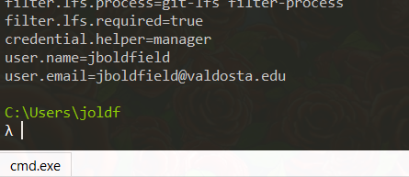

**Tutorial 2**

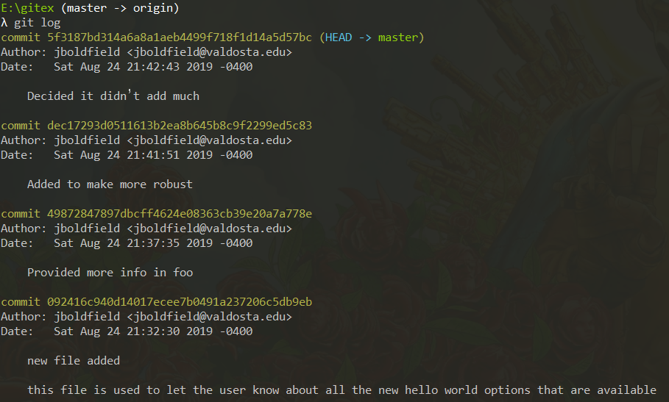

**Tutorial 3**

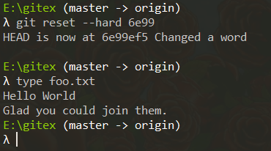

**Tutorial 4**

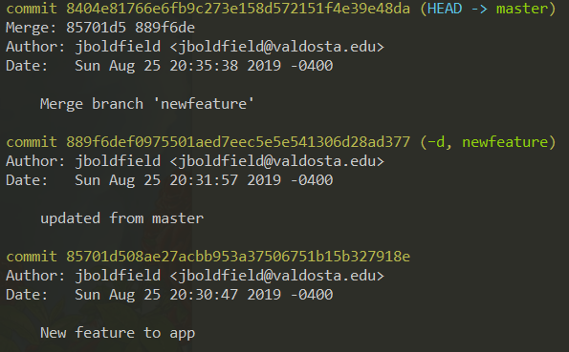

**Tutorial 5**

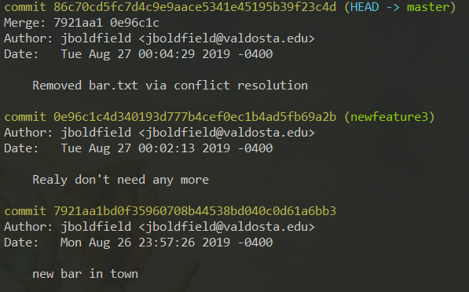

**Tutorial 6**

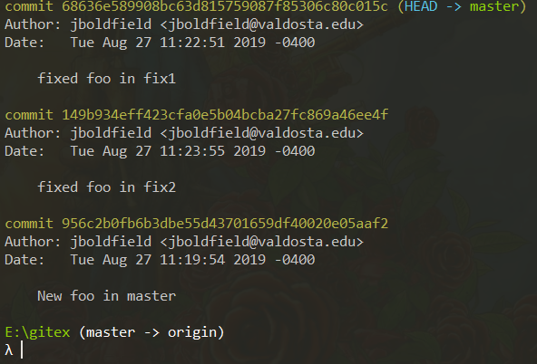

**Tutorial 7**

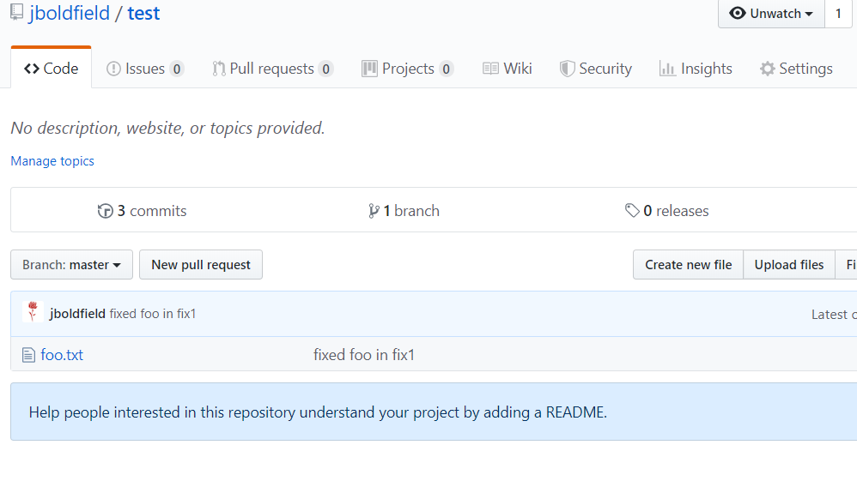

**Tutorial 8**

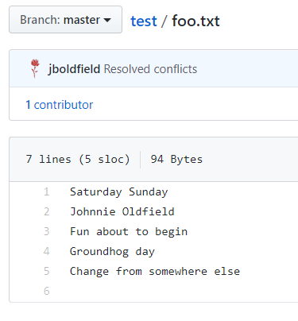

**Tutorial 9**

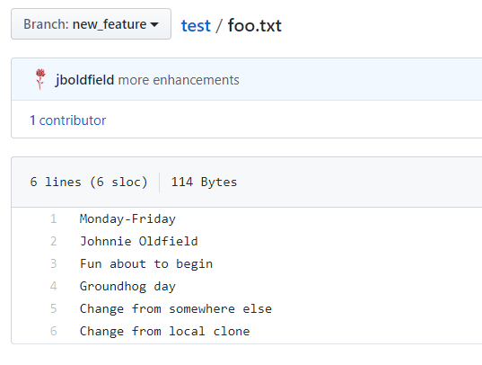

**Tutorial 10**

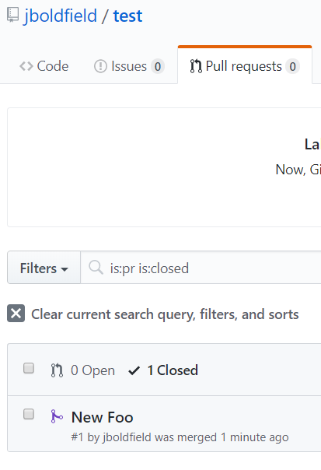

**Tutorial 11**

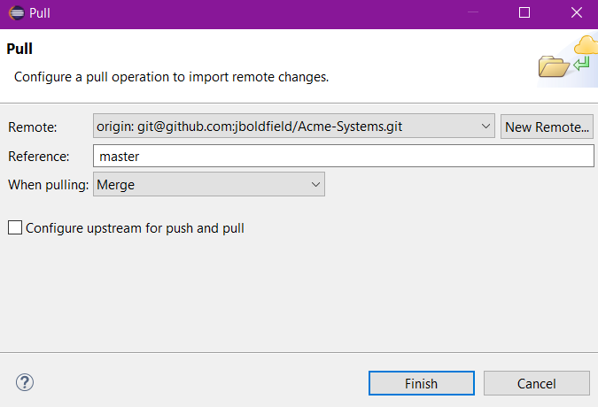

**Tutorial 12**

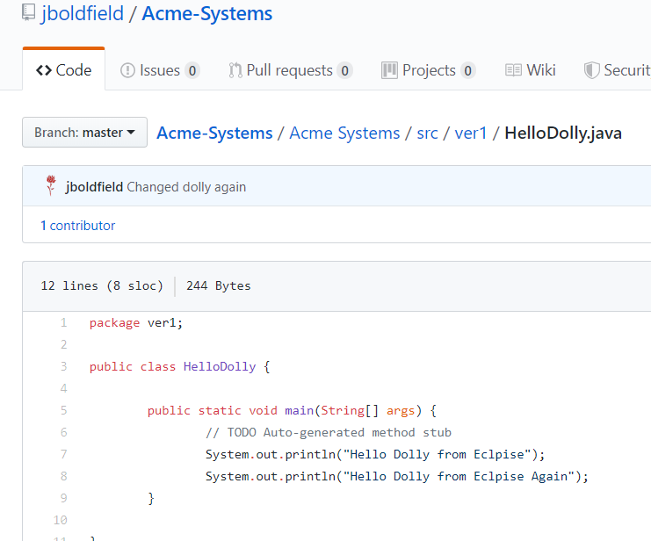

**Tutorial 13**

